Framework : Framework provide standard structure which help to develop the enterprise level application. If we develop any application using any framework indirectly you are following standard. Design pattern: Design pattern is known as best practise or solution of repeating problem. Framework is an implementation of all design pattern.
Singleton
Factory method
Bean
Service layer
Dao layer
Resource layer
Mvc design pattern.
GOF.
If we develop any application using any framework 70 to 80% code taken care by framework. Framework is not a final product it is protocol or template. We need to write the code base upon our requirement to make the final code.
Framework provided lot of api ( classes and interfaces) which help to do specific task.

Collection Framework:
.net framework
Django framework with python
Angular framework / React JS is library with redux tools

Struts : Struts is an open source web framework provided by Apache. Struts internally follow MVC. It provided lot of api for view layer, controller layer and model layer etc. Struts mainly focus on controller layer. Struts is known as controller centric framework.
JSF : Java Server Faces : JSF also is an open source framework provided by oracle. JSF internally use MVC. Provided lot of api to improve view, controller and model layer. JSF is known as view centric framework.
JSP Vs JSF

JSF Vs Angular / React JS

Hibernate : Hibernate is an open source framework which is base upon ORM (Object relation mapping) etc. Hibernate is mainly improve DAO layer.
JPA : Java persistence API
Spring Framework

Spring is an open-source layer architecture or onion architecture framework. Spring also known as light weighted framework.

Spring modules
- Spring core
- Spring context
- Spring mvc : model view controller.
Spring mvc is known as model centric framework
- Spring dao
- Spring orm it allow to integrate with JPA or Hibernate
- Spring rest we can create rest full web service
- Spring boot
- Spring cloud
- Spring micro service
- Spring security
- Spring integration

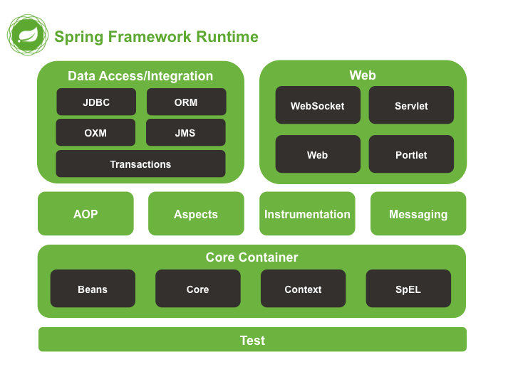
Container: run time environment.
MVC application using servlet and JSP. Web container is a part of server which is responsible to take the life object servlet and jsp.
JavaBean class object, service class object, dao class and resource class object we created.
Spring container

Spring Framework

IOC : Inversion of control : it is a programming design pattern. According to IOC. In place of creating as well as maintaining any resources (object creation, file handling, thread management, database connection) explicitly. Allow to maintain by container. If container create or maintain. It maintain the properly. Base upon your requirement pull it and use it and leave it.

Employee emp = new Employee();

Employee emp1 = (we pull the object from container).

Spring container part of few jar file with configuration file. Spring container create as well as maintain the resource like object creation of JavaBean class. generally in spring framework we call JavaBean class as POJO class (Plain Old Java Object) this class not to extends or not to implement any pre defined class or interface.

IOC is concept.
DI : Dependency Injection
DI is an implementation of IOC. Using DI concept we pull the resource from container.
Spring support two type of DI
- Constructor base DI
- Setter base DI

We can achieve constructor base and setter base DI using
xml configuration as well as annotation base.

